Govt. High School
Sindhi Jamaat Co-Operative Housing Society, Karachi
Final Term Examination 2024-25
Paper: G. K | Class: Three | Total Marks: 75
Name: ___________________ |  | Date: ____________

Section “A”
Q1: Choose the correct answer: (7)
- What is the main source of water on earth?
- Wells b) ocean c) rain
- Which of the following is not natural resource?
- Coal b) water c) gold
- What does a compass help us find?
- The weather b) the cardinal directions c) time
- The sun rises in the _________ direction.
- North b) east c) west
- Which force help to open and close the door?
- Push and pull b) gravity c) bending
- What should we do if we have a conflict with a friend?
- Fight b) ignore them c) talk and solve the problem
- Who invented the light bulb?
- Albert Einstein b) Thomas Edison c) Nikola tesla

Q2- fill in the blanks. (5)
- Minerals like gold and silver used to make __________
- ______ is used for making decorative items.
- _________ help people to communicate easily.
- The light bulb was invented by ______
- There are __________ main cardinal directions.

Q3: True or false (5)
1- Forests keep the air clean
2- Cutting tress is good.
3- The light bulb is invented in 1879.
4- Old computer was big.
5- A push and pull are a force.

SECTION “B”
Q4: Answer the following questions. (16)
- What are machines?
- What (NGOs) stand for?
- What covers most of the earth’s surface?
- Name some examples of minerals.

Q5: write the four cardinal directions according to your position. (4)

_______________
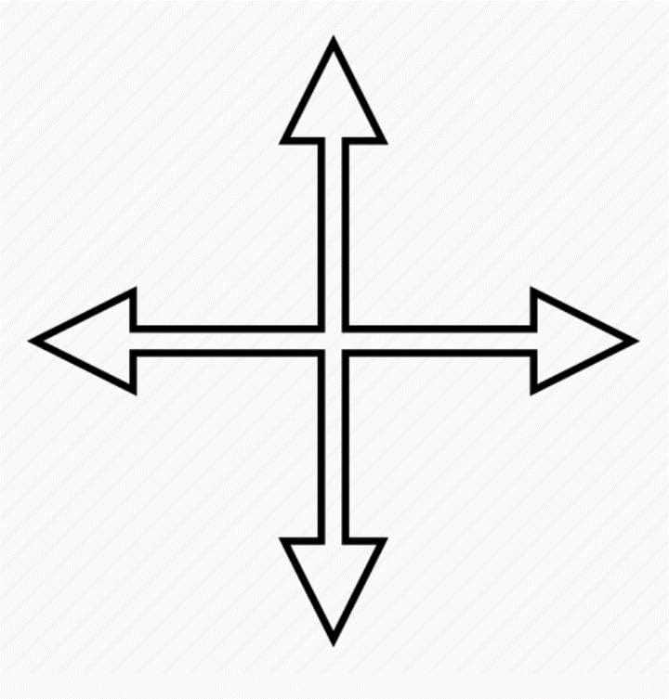

___________ ___________

______________

Q6: Write the name of inventions that invented by these inventors. (3)

INVENTORS | INVENTIONS
Thomas Edison
Martin copper
Charles Babbage

Q7: look at the picture. Write the type of simple machine in the given space under the picture. (5)
1-

2-

3-

4-

5-

Q8: look at the picture carefully. force is being applied to change the shape of objects. can you name the type of force which will change their shape? (4)

Q9: draw the [picture of the park, you would like to play. (6)

Q10: write two important rights of children. (2)
1- ___________________________________________________________________________
2- ___________________________________________________________________________
Q11: write 6 planets name. (3)
1-_____________
2-_____________
3-_____________
4-_____________
5-_____________
6-_____________

